**YEAR: 8**

**2023**

**SUBJECT: Science**

**Semester 2 Term 4**

TEST: Chemistry (Elements and equations)

TIME: 55 minutes

QUESTIONS:

**Total: _______ / 37**

**10 Multiple Choice (10 marks)**

**9 Short Answer (28 marks)**

## Multiple Choice:

1. Matter that is only composed of one type of atom is called a(n) ……………….
2. Element
3. Compound
4. Molecule
5. Mixture
6. Which one of the following gases is a compound?
7. H2
8. CO2
9. O2
10. N2
11. The atomic number of an element tell us:
12. The weight of its atoms
13. When it was discovered
14. The number of neutrons in one atom
15. The number of protons in one atom
16. The molecular formula for acetaldehyde is C2H4O. It contains the following atoms:
    1. 1x carbon, 2x hydrogen, 4x oxygen
    2. 1x carbon, 2x helium, 4x oxygen
    3. 2x carbon, 4x hydrogen, 1x oxygen
    4. 2x carbon, 4x helium, 1x oxygen
17. The electrical conductivity for four metals at different temperatures is shown in the graph below.

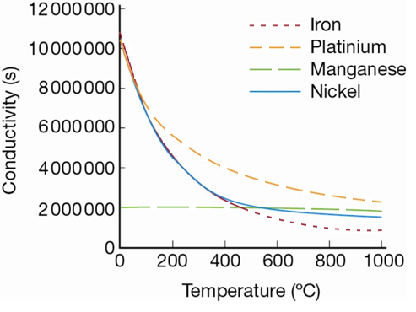

According to this graph, the best conductor at 900°C is:

* 1. Iron
  2. Manganese
  3. Platinum
  4. Nickel

1. A student carries out an experiment to determine the effect of different types of salt solutions on an iron nail. Identify the purpose of the test tube containing the nail and water only.

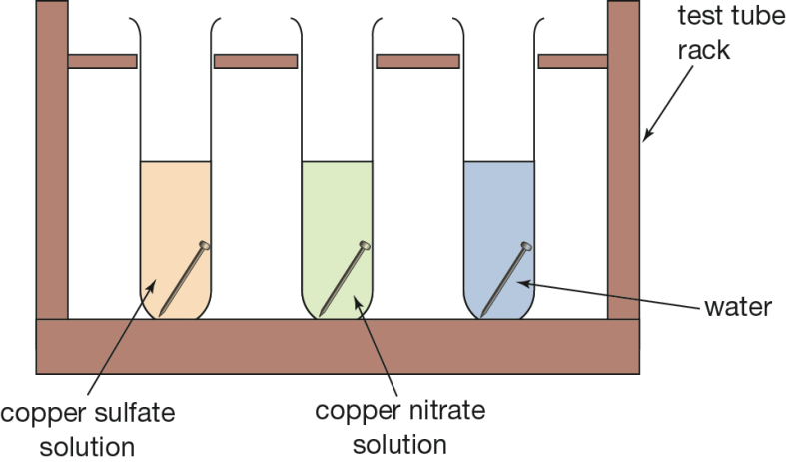

* 1. It allows a comparison between copper nitrate and copper sulfate
  2. The water is added to test the strength of the nail
  3. It is a control for the experiment
  4. All of the answers are correct.

1. Identify which of the following compounds is most likely to have molecules like that of the diagram below:
2. Sodium Chloride, NaCl
3. Ammonia, NH3
4. Methane, CH4
5. Water, H2O
6. Identify the correct statement about the properties of compounds.
   1. The properties of compounds are impossible to describe
   2. The properties of compounds are different to those of the elements they are made from
   3. The properties of compounds are the average properties of the elements that make them up
   4. The properties of compounds are the same as the elements they are made from
7. Tap water is best described as:
   1. An element
   2. A compound
   3. A mixture
   4. An alloy
8. Recall how the electron cloud and nucleus are held together
   1. They have opposite electronic charge that attracts them together.
   2. They have a similar electronic charge that attracts them together
   3. They are chemically bonded to each other
   4. The gravitational pull of the heavy nucleus attracts the light electrons

## Short Answer Questions

### Must Questions

1. For the below element label or name what each of the arrows tell us about the element:

(0 marks)

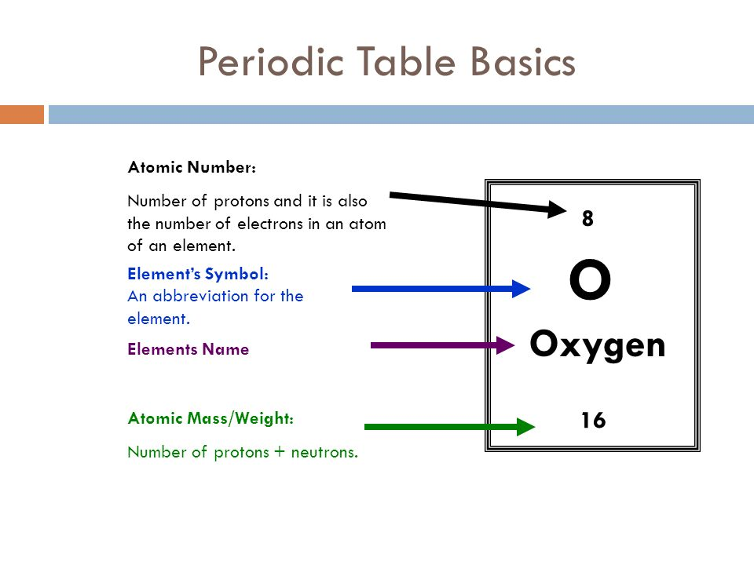

1. Complete the table below with the names of the 3 subatomic particles and their charges: (2 marks)

|  |  |  |  |
| --- | --- | --- | --- |
|  | **Subatomic Particle:** | | |
| **NAME** | PROTON |  |  |
| **CHARGE** |  |  | NEGATIVE |

1. Complete the tables below with the missing element name or symbol:

(2 marks)

|  |  |
| --- | --- |
| **ELEMENT NAME** | **ELEMENT SYMBOL** |
| Potassium |  |
| Carbon |  |
|  | Cu |
|  | He |

1. **Provide** the name and chemical formula for the molecule shown below: (2 marks)

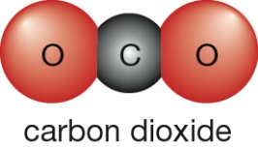

Name: _____________________________________________________________________

Chemical Formula: ____________________________________________________________

### Should Questions

1. Balance the followingChemical Equations: (2 marks)
   1. ____ H2 + ____ O2 → ____ H2O
   2. ____ NaBr + ____ CaF2 → ____ NaF + ____ CaBr2
2. **Calculate** the number of protons, neutrons and electrons in a calcium atom with the atomic symbol ${}_{20}^{41}{Ca}$ (3 marks)

Protons: ___________ Neutrons: ___________ Electrons: ­___________

1. Use your understanding of the periodic table to explain why **CO** and **Co** are not the same substance. (2 marks)

|  |
| --- |
|  |
|  |
|  |
|  |

1. Using the following symbols draw in the boxes below, an example of each description:   
    (4 marks)
2. An Element ii. A Compound iii. Mixture of elements iv. Mixture of   
    compounds

### Could Questions

1. Use the information about the following element, to create a diagram of the atom with the correct number of subatomic particles. (4 marks)

|  |  |
| --- | --- |
|  |  |

20) (6 marks)

A) Below is the word equation for rusting:

Iron + Oxygen gas 🡪 Iron oxide

Write the balanced chemical equation for the above reaction

_______________________________________________________________________________

Which of the four main types of reactions is this : ___________________________________

B) The hydrogen pop test can be used to determine the presence of hydrogen gas:

Magnesium + hydrochloric acid 🡪 magnesium chloride + hydrogen gas

Write the balanced chemical equation for the above reaction

_______________________________________________________________________________

Which of the four main types of reactions is this : ___________________________________

C) Cooper carbonate can be heated.

Copper carbonate 🡪 Copper oxide + Carbon dioxide gas

Write the balanced chemical equation for the above reaction

_______________________________________________________________________________

Which of the four main types of reactions is this : ___________________________________

|  |  |  |  |
| --- | --- | --- | --- |
|  | **Must** | **Should** | **Could** |
| **Questions** | 1-9, 11-14 | 15-18 | 10,19,20 |
| **Number of marks** | 18 | 12 | 8 |
| **Percentage of test (%)** | 47% | 31% | 22% |

**Finished? Try this WordSearch 😊**

**(No, It is not worth any marks!)**

